# high value customer identification

ecom <- read.csv(file.choose(), stringsAsFactors = FALSE)

View(ecom)

#structure of dataset

str(ecom)

#descriptive stats

summary(ecom)

#customer Id's missing, delete observations

dim(ecom)

#remove redundant variable

ecom$X <- NULL

is.na(ecom$CustomerID)

ecom_1 <- na.omit(ecom)

dim(ecom_1)

#aggregate the data at customer Id level

library(dplyr)

library(lubridate)

ecom_1$InvoiceDate <- dmy(ecom_1$InvoiceDate)

#find date of last order

#max value of invoice date

max(ecom_1$InvoiceDate)

# 2017-12-07

#difference between last order date and transaction date

ecom_1$days_passed <- as.Date('2017-12-07') - ecom_1$InvoiceDate

View(ecom_1)

#remove those rows where quantity was returned

ecom_2 <- ecom_1 %>% filter(Quantity>=0)

#number of transactions

ecom_3 <- ecom_2 %>% group_by(CustomerID) %>% summarise(no_of_trans=as.numeric(n_distinct(InvoiceNo)),

no_of_dist_items=n_distinct(StockCode),

total_quant=sum(Quantity),

total_value=sum(Quantity*UnitPrice),

latest_order=as.numeric(min(days_passed)))

View(ecom_3)

#cluster data

#unsupervised - no need to divide into test and training data

#normalize data

#no need for customer ID

ecom_sc <- scale(ecom_3[-1])

View(ecom_sc)

#to check if it has been scaled or not

# mean=0 for each column

apply(ecom_sc,2,mean)

# std deviation

apply(ecom_sc,2,sd)

#distnace between two points of cluster

distance <- dist(ecom_sc,method = 'euclidean')

#linkage algorithm

clus_model <- hclust(distance,method = 'ward.D')

#to know optimum number of cluster in dataset

#elbowcurve

library('factoextra')

fviz_nbclust(ecom_sc,kmeans,method = 'wss')

# from elbow curve we get the optimum number of cluster=4

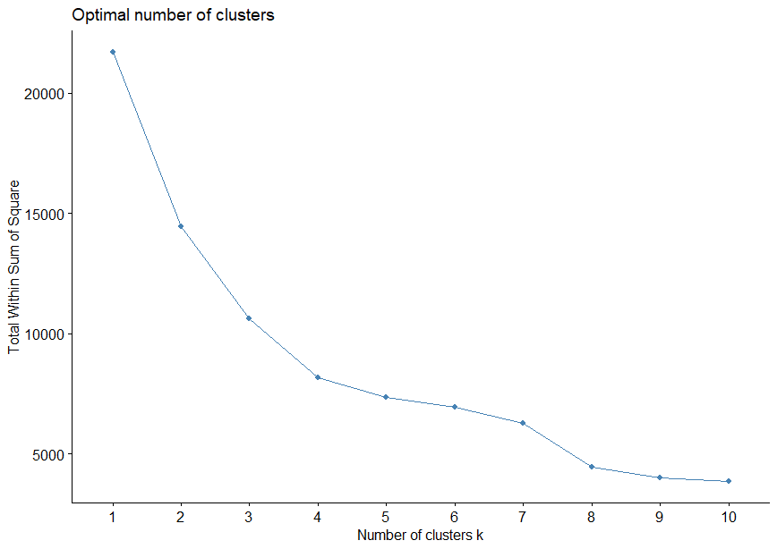

#silhoette metric - if the points are correctly assigned

# -1 to +1

fviz_nbclust(ecom_sc,kmeans,method = 'silhouette')

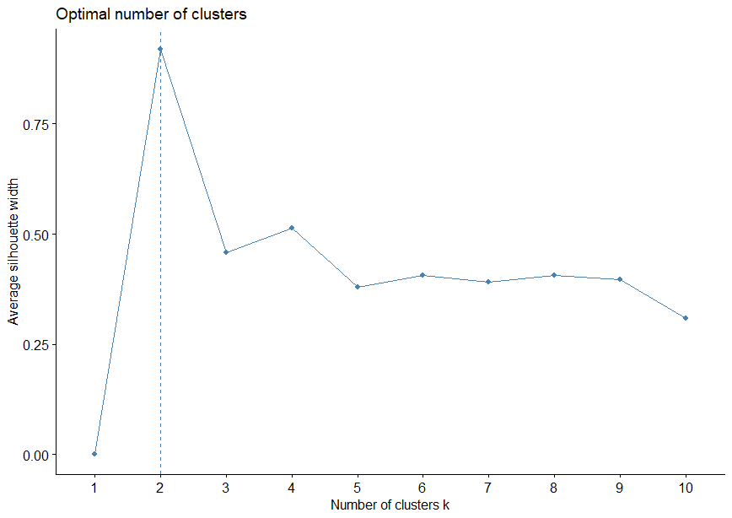

#lets take optimum as n=4

#kmeans clustering

clus_model <- kmeans(ecom_sc,4,iter.max = 10)

#assign each point to the cluster from 1-4

ecom_3$cluster <- clus_model$cluster

View(ecom_3)

#cluster demographics

colnames(ecom_3)

clus_demo <- ecom_3 %>% group_by(cluster) %>% summarise(mean(no_of_trans),mean(no_of_dist_items),mean(total_quant),mean(total_value),

mean(latest_order), n())

View(clus_demo)

# to further break it down

#filter by cluster 2 and apply same methodology